Control Lesson 1 Vehicle Dynamics

[1. Sebastian Introduction](https://classroom.udacity.com/nanodegrees/nd787/parts/3619d672-ce5b-4a29-8a15-172cb667b5bb/modules/b78ec22c-5afe-444b-8719-b390bd2b2988/lessons/4cd7a5c4-12ad-4853-86cb-759d3833e856/concepts/6065be8d-9dda-4ed0-b061-753b71422655)

<https://www.youtube.com/watch?v=dzGdwiADfjs>

[2. Introduction to Vehicle Dynamics](https://classroom.udacity.com/nanodegrees/nd787/parts/3619d672-ce5b-4a29-8a15-172cb667b5bb/modules/b78ec22c-5afe-444b-8719-b390bd2b2988/lessons/4cd7a5c4-12ad-4853-86cb-759d3833e856/concepts/a7acb6ba-6fb5-4596-81eb-39e6466787bc)

<https://www.youtube.com/watch?v=EME6cpJF_aw>

# **Lesson Outline**

In this lesson you will learn about the physics which underlies motion in one and two dimensions. We will cover 3D dynamics in the fourth lesson of this course.

#### **Part 1 - Basic (1D) Quadrotor Physics**

We're going to go *quickly* through this section. We assume you've taken basic physics before and this is mostly a review.

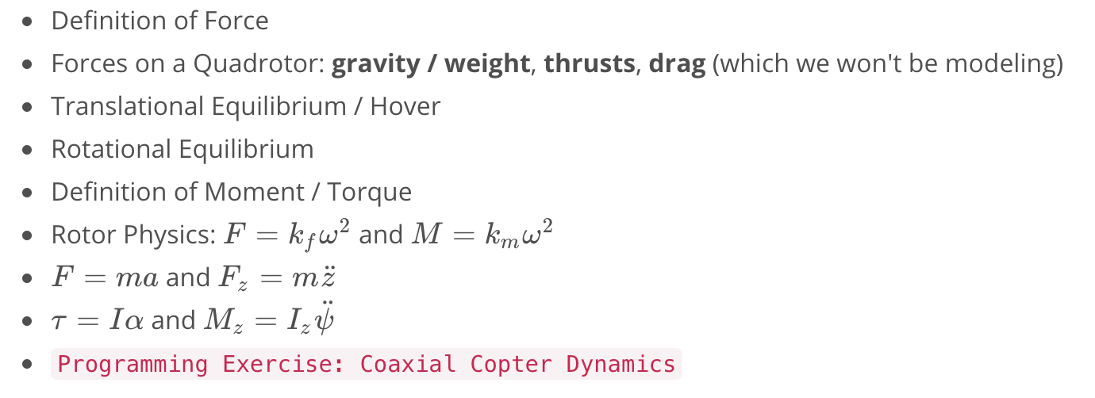

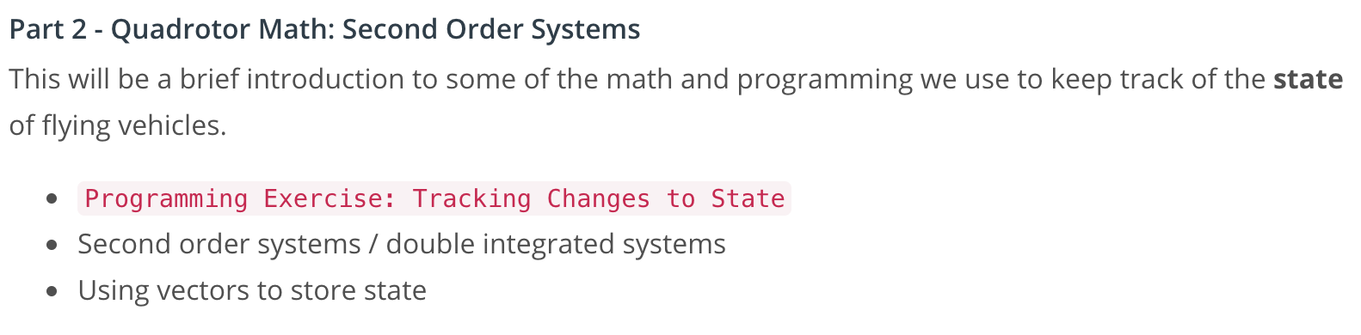

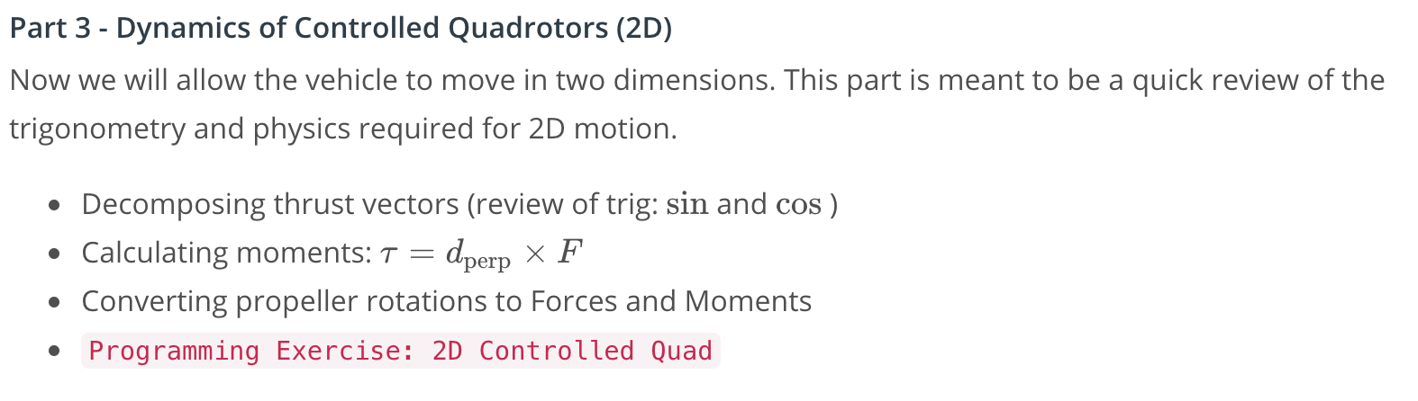

[3. The Forces on A Quadrotor](https://classroom.udacity.com/nanodegrees/nd787/parts/3619d672-ce5b-4a29-8a15-172cb667b5bb/modules/b78ec22c-5afe-444b-8719-b390bd2b2988/lessons/4cd7a5c4-12ad-4853-86cb-759d3833e856/concepts/418592e7-84ed-4d34-a150-3af4feb819ae)

<https://www.youtube.com/watch?v=F8BvMsR2VyU>

## **Quadrotor Intuition**

Imagine looking at a quadrotor from the side. What happens when the thrust from the left rotors is bigger than the thrust from the right? What happens when they're equal?

You probably already have a good intuitive sense for how some of this control works.

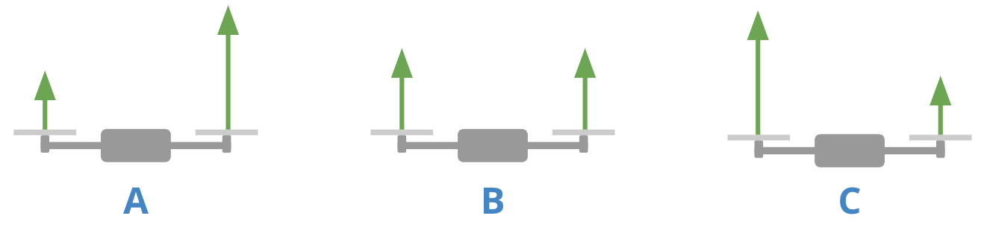

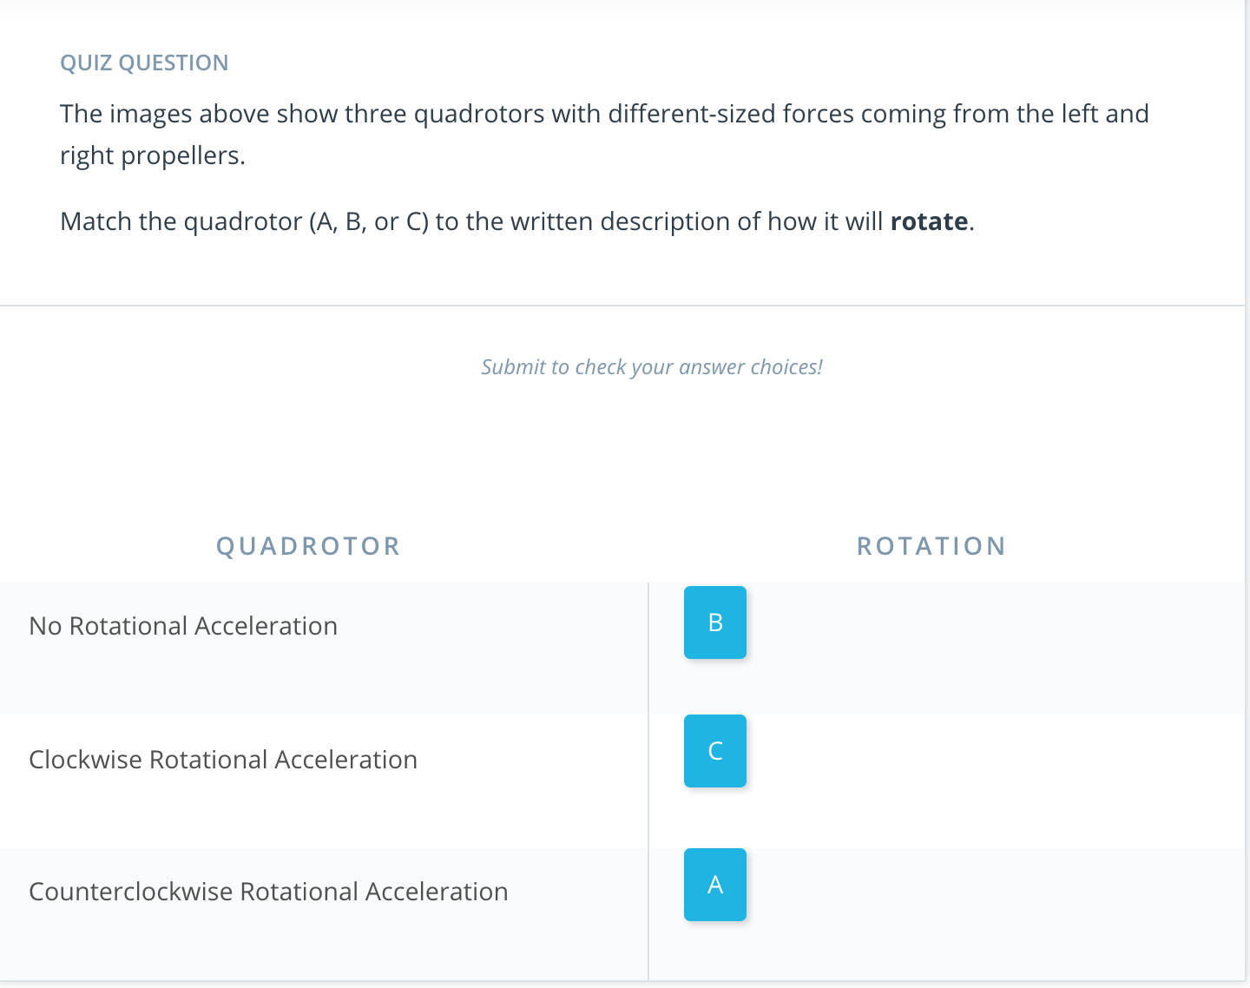

[4. Force and Translational Equilibrium](https://classroom.udacity.com/nanodegrees/nd787/parts/3619d672-ce5b-4a29-8a15-172cb667b5bb/modules/b78ec22c-5afe-444b-8719-b390bd2b2988/lessons/4cd7a5c4-12ad-4853-86cb-759d3833e856/concepts/9781dd9e-cd64-44bc-81a7-af578d8d7ac1)

<https://www.youtube.com/watch?v=0bEHYCkPGTI>

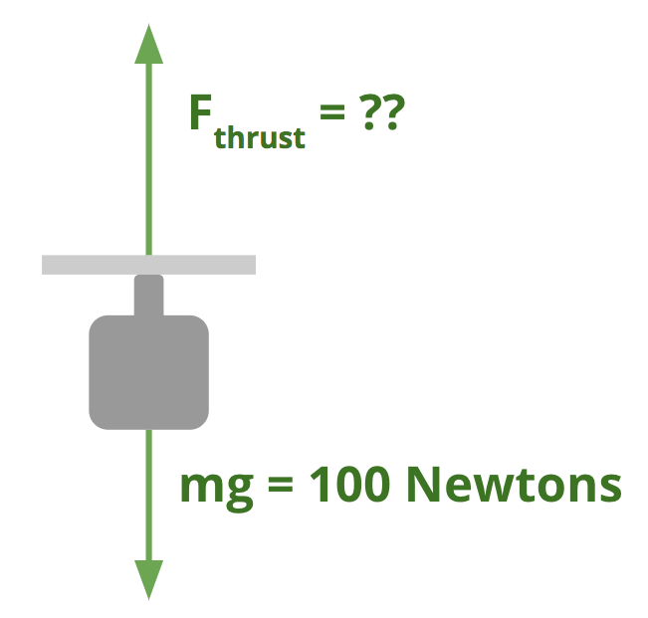

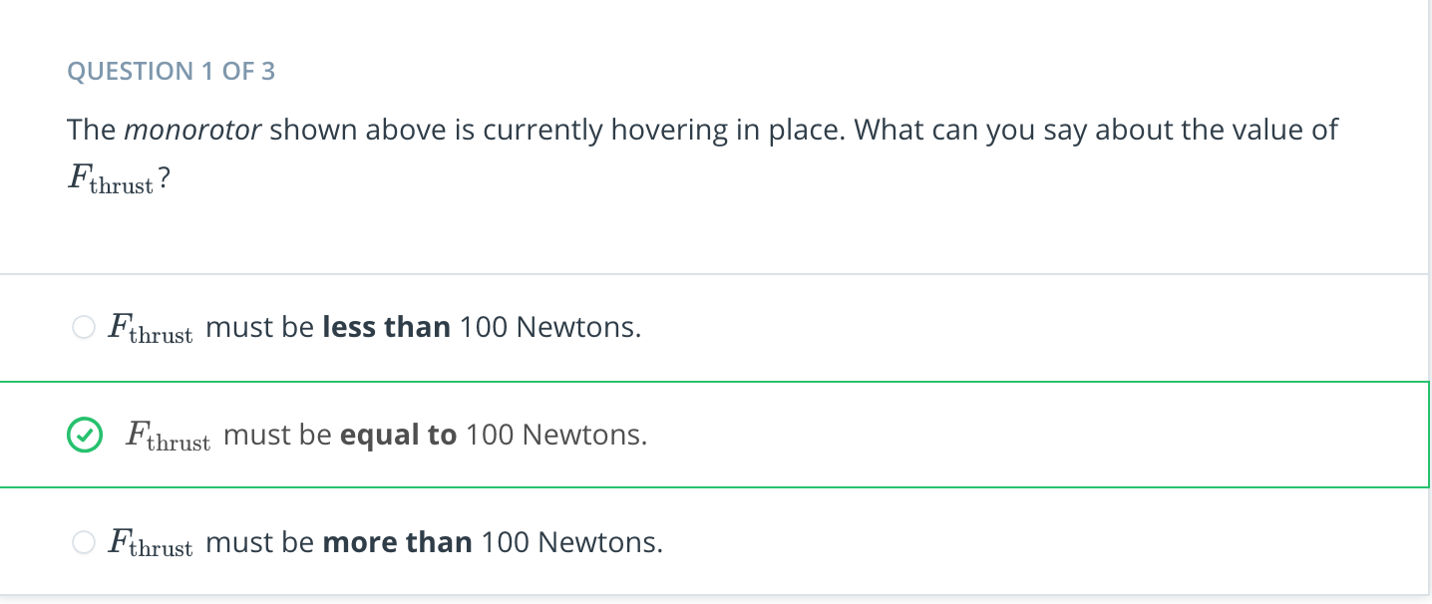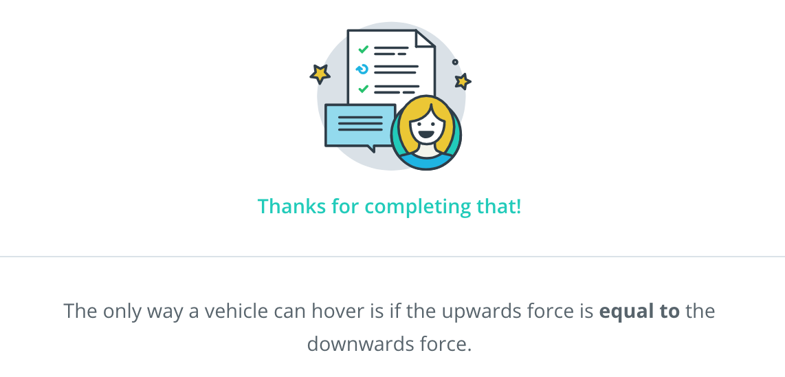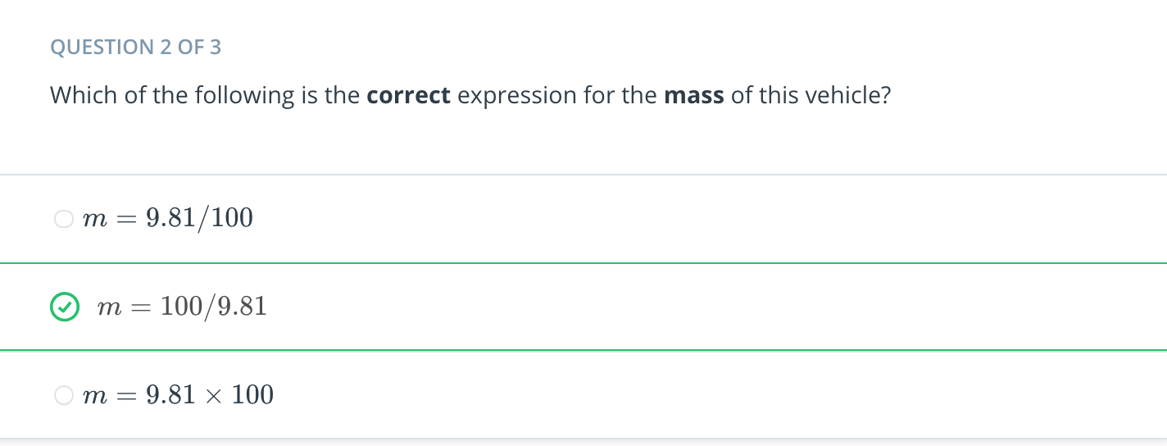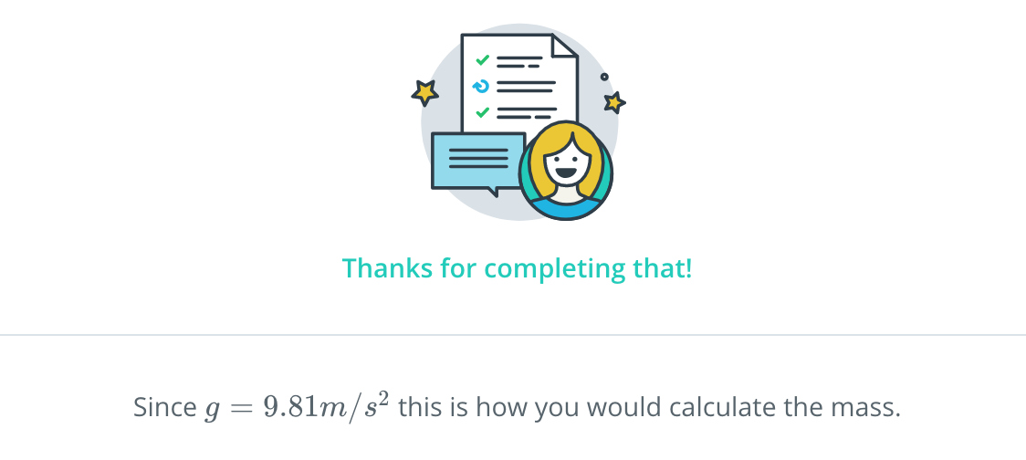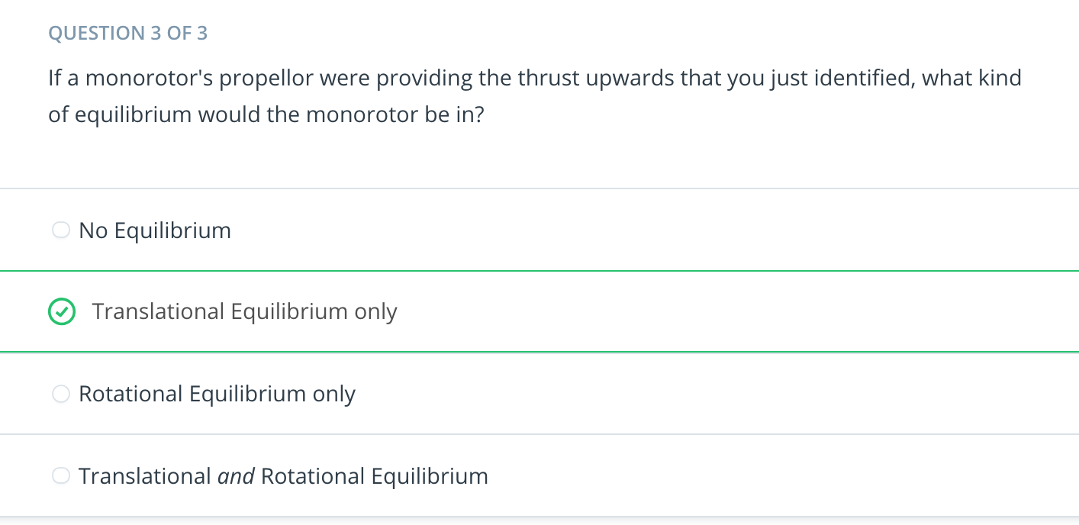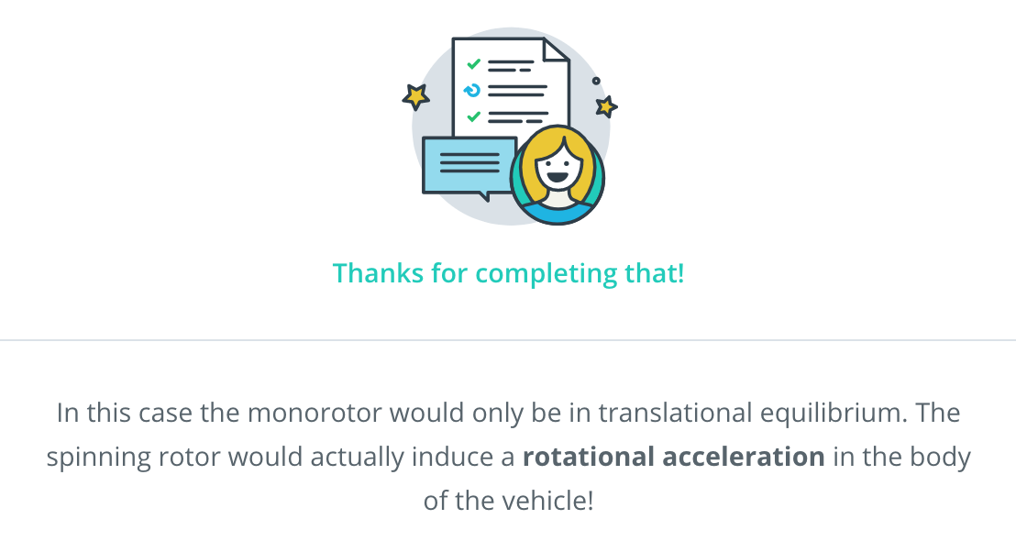

[5. Rotational Equilibrium 1](https://classroom.udacity.com/nanodegrees/nd787/parts/3619d672-ce5b-4a29-8a15-172cb667b5bb/modules/b78ec22c-5afe-444b-8719-b390bd2b2988/lessons/4cd7a5c4-12ad-4853-86cb-759d3833e856/concepts/ebba83b6-ec48-45ea-82a7-c844e90f6e96)

<https://www.youtube.com/watch?v=S9X9sJIeDIk>

The monorotor from [this video](https://www.youtube.com/watch?v=P3fM6VwXXFM) is pretty amazing! Notice how the body of the vehicle rotates in the opposite direction of the rotor.

[6. Rotational Equilibrium 2](https://classroom.udacity.com/nanodegrees/nd787/parts/3619d672-ce5b-4a29-8a15-172cb667b5bb/modules/b78ec22c-5afe-444b-8719-b390bd2b2988/lessons/4cd7a5c4-12ad-4853-86cb-759d3833e856/concepts/cf2aecb8-bf85-401e-a98b-ca61bfb49381)

<https://www.youtube.com/watch?v=scNi0w5aajM>

[7. Rotor Physics](https://classroom.udacity.com/nanodegrees/nd787/parts/3619d672-ce5b-4a29-8a15-172cb667b5bb/modules/b78ec22c-5afe-444b-8719-b390bd2b2988/lessons/4cd7a5c4-12ad-4853-86cb-759d3833e856/concepts/35ebb5e5-1dca-4301-99ac-fb26639705e6)

<https://www.youtube.com/watch?v=DMXPYxnocdE>

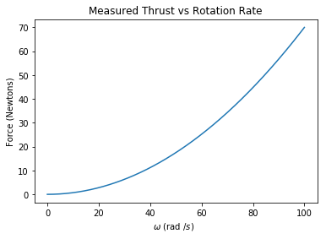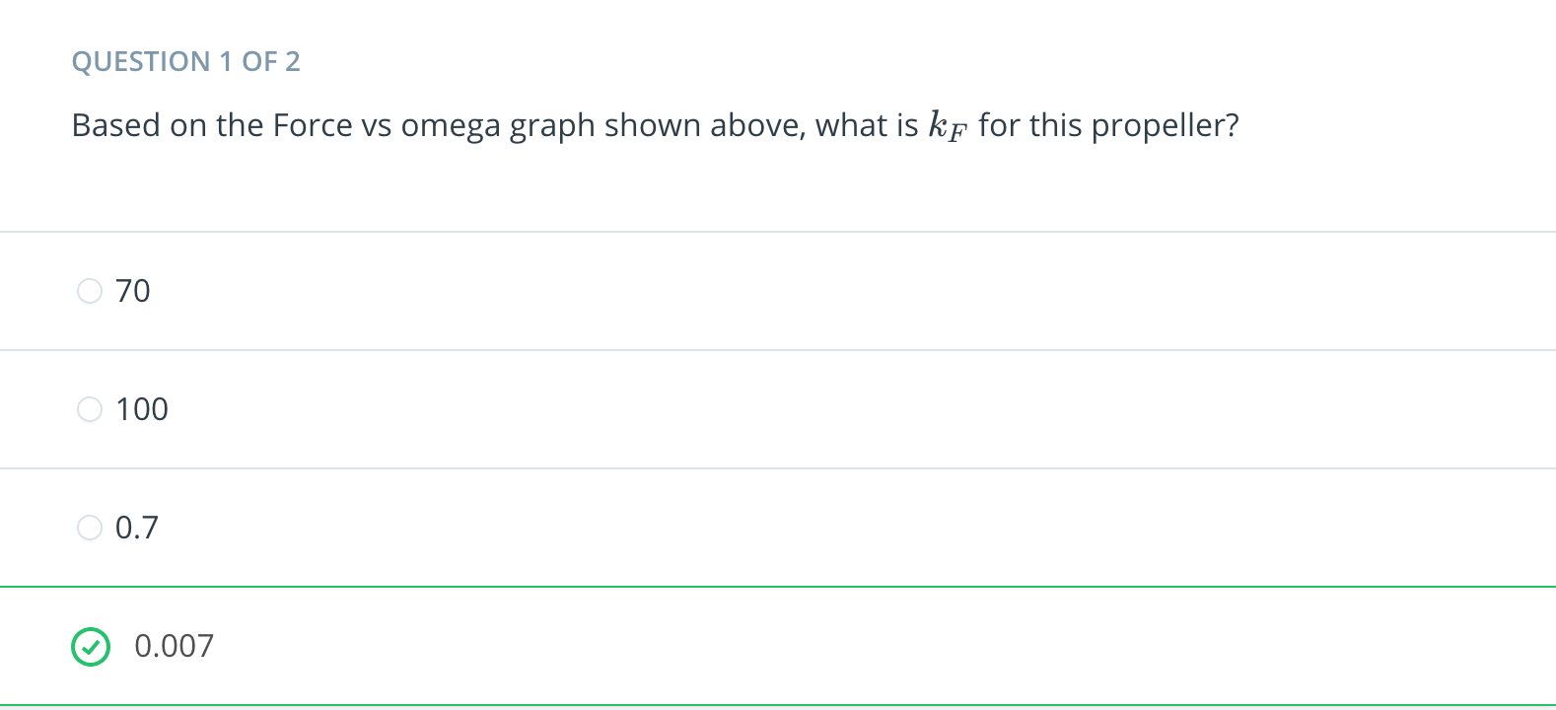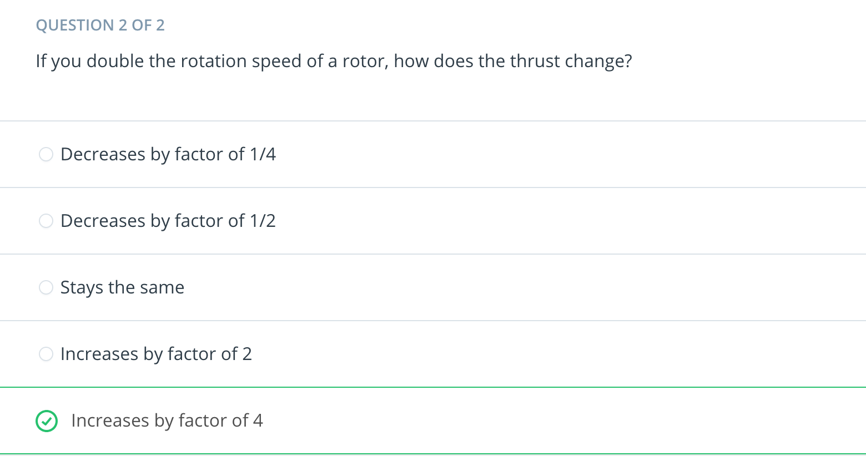

[8. Unbalanced Forces Cause Linear Acceleration](https://classroom.udacity.com/nanodegrees/nd787/parts/3619d672-ce5b-4a29-8a15-172cb667b5bb/modules/b78ec22c-5afe-444b-8719-b390bd2b2988/lessons/4cd7a5c4-12ad-4853-86cb-759d3833e856/concepts/e3d3a81b-e94f-425b-b8e8-4dd973de033f)

<https://www.youtube.com/watch?v=7TiBKJsKwR0>

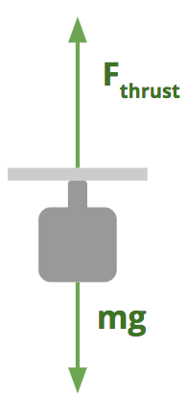

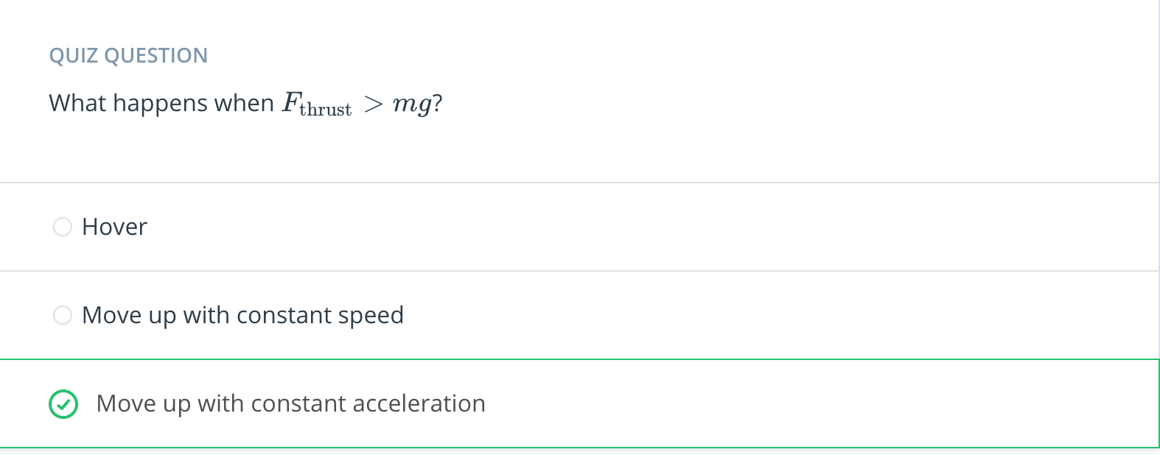

[9. F Equals MA](https://classroom.udacity.com/nanodegrees/nd787/parts/3619d672-ce5b-4a29-8a15-172cb667b5bb/modules/b78ec22c-5afe-444b-8719-b390bd2b2988/lessons/4cd7a5c4-12ad-4853-86cb-759d3833e856/concepts/35af4878-8cc8-4d5e-b6d9-46d2f6fb5c2a)

<https://www.youtube.com/watch?v=dA82iMkJMC4>

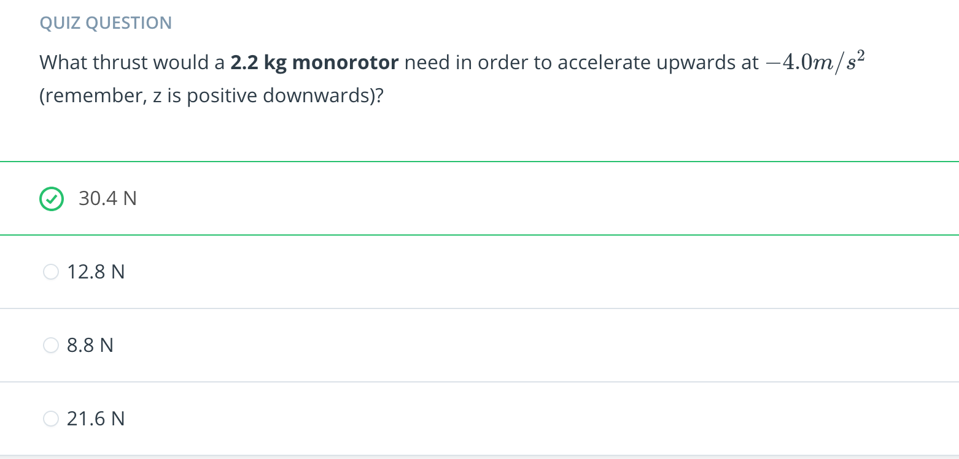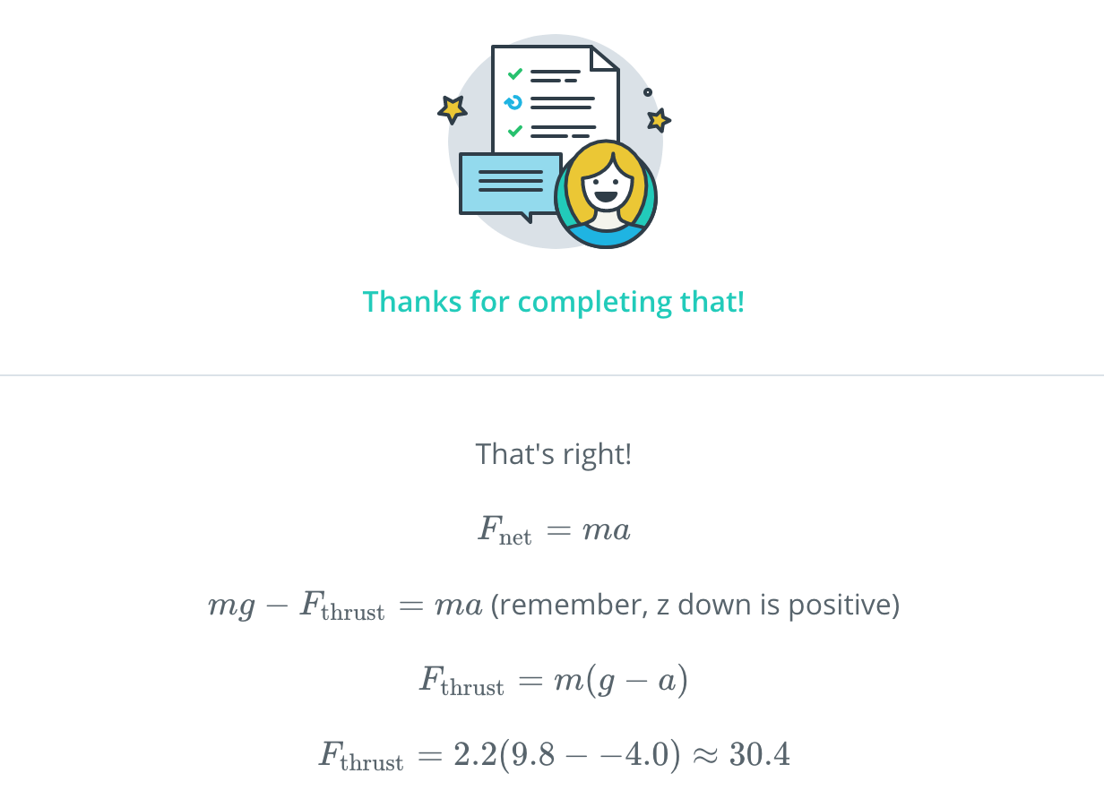

[10. Unbalanced Moments cause Rotational Acceleration](https://classroom.udacity.com/nanodegrees/nd787/parts/3619d672-ce5b-4a29-8a15-172cb667b5bb/modules/b78ec22c-5afe-444b-8719-b390bd2b2988/lessons/4cd7a5c4-12ad-4853-86cb-759d3833e856/concepts/ef090e98-ebd6-41a5-a320-4b28cb26f679)

<https://www.youtube.com/watch?time_continue=3&v=qOXE8_cZRzU>

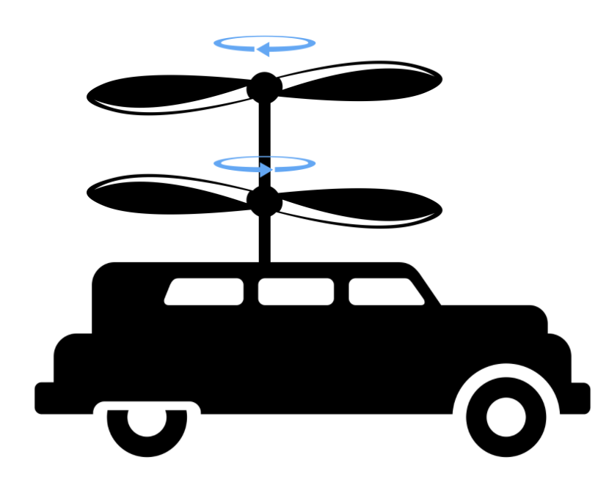

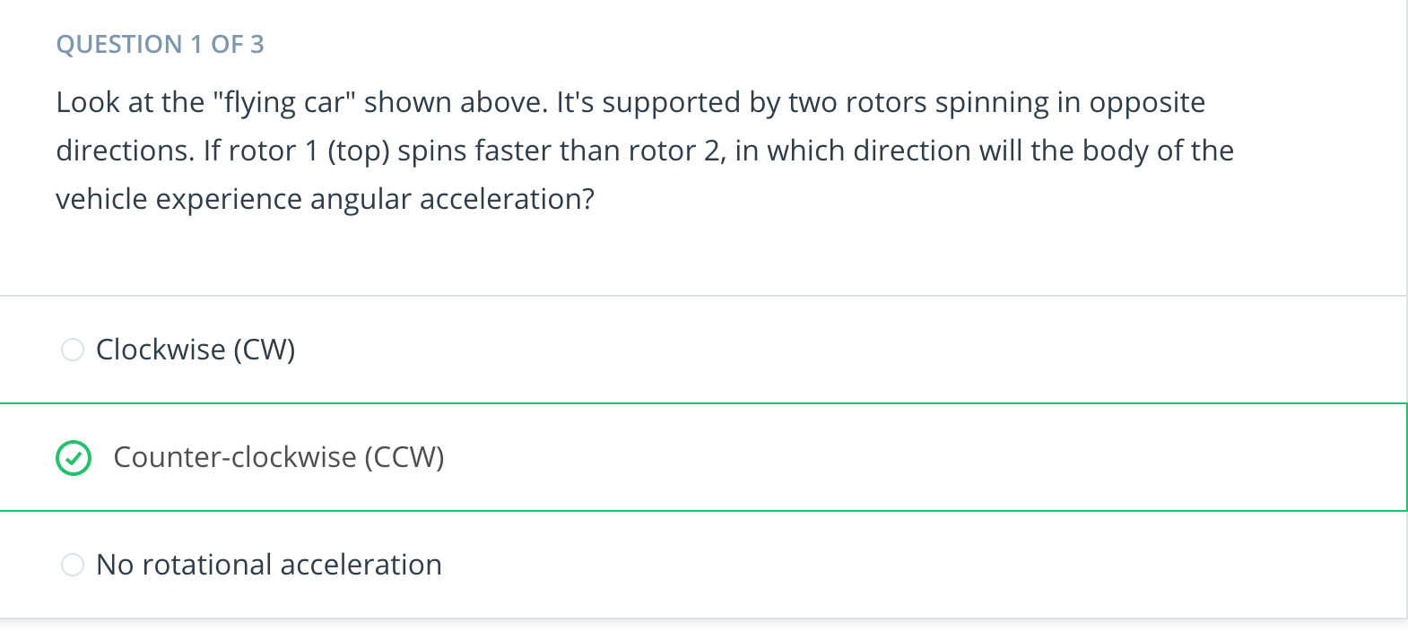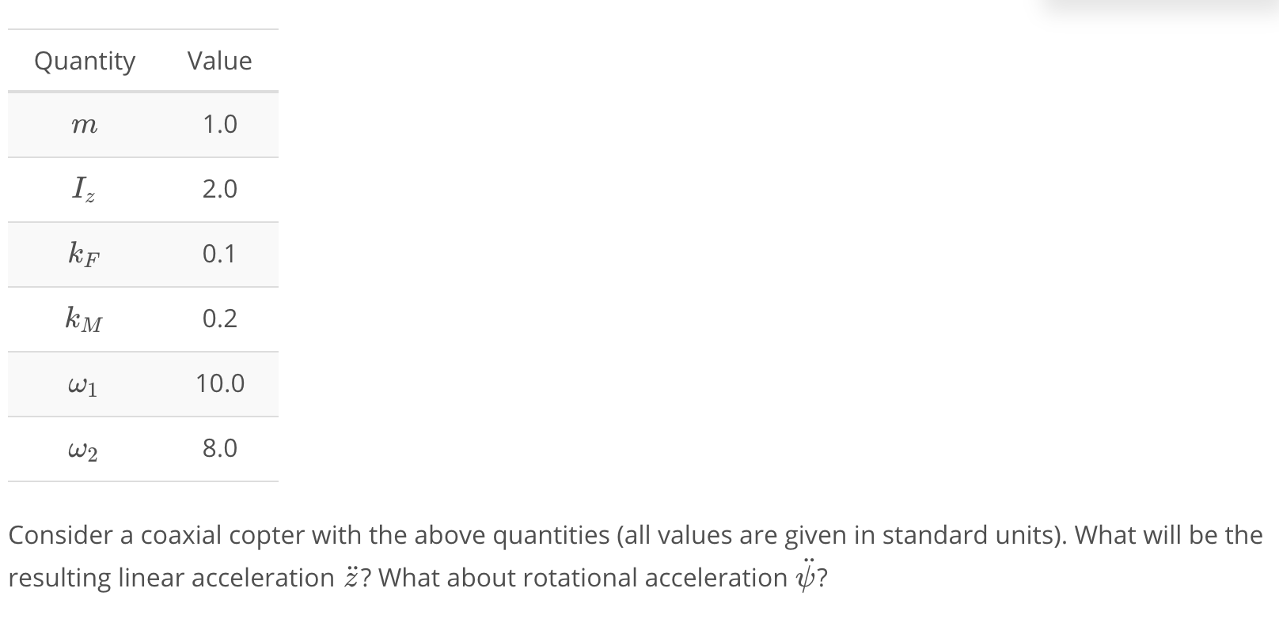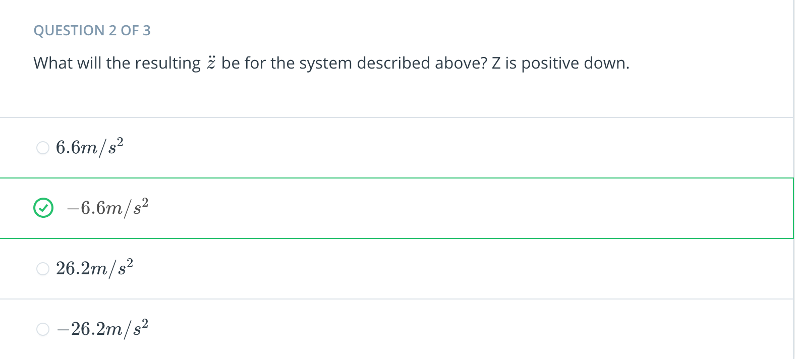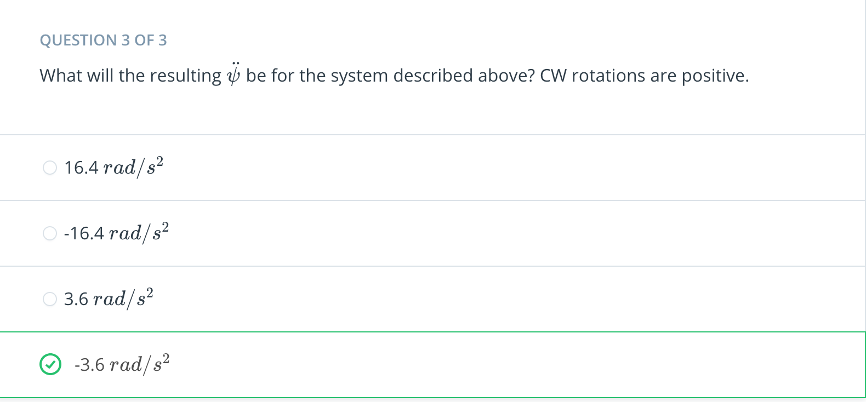

[11. Coaxial Drone Dynamics Exercise](https://classroom.udacity.com/nanodegrees/nd787/parts/3619d672-ce5b-4a29-8a15-172cb667b5bb/modules/b78ec22c-5afe-444b-8719-b390bd2b2988/lessons/4cd7a5c4-12ad-4853-86cb-759d3833e856/concepts/b29f7b3e-2a0f-4880-b51b-ec46c89b799c)

[Coaxial Drone Dynamics.ipynb](https://viewb313237d.udacity-student-workspaces.com/notebooks/1.%20Coaxial%20Drone%20Dynamics.ipynb)

[12. Coaxial Dynamics Explained](https://classroom.udacity.com/nanodegrees/nd787/parts/3619d672-ce5b-4a29-8a15-172cb667b5bb/modules/b78ec22c-5afe-444b-8719-b390bd2b2988/lessons/4cd7a5c4-12ad-4853-86cb-759d3833e856/concepts/fb22f9f0-606c-4910-8e33-c192c5b790a0)

<https://www.youtube.com/watch?time_continue=1&v=0XkkWGxmZDM>

[13. Tracking Changes to State](https://classroom.udacity.com/nanodegrees/nd787/parts/3619d672-ce5b-4a29-8a15-172cb667b5bb/modules/b78ec22c-5afe-444b-8719-b390bd2b2988/lessons/4cd7a5c4-12ad-4853-86cb-759d3833e856/concepts/0b98640e-db8c-40a0-bc83-8d629e62acd6)

<https://www.youtube.com/watch?v=O25yHC541qo>

[14. Tracking Changes to State Exercise](https://classroom.udacity.com/nanodegrees/nd787/parts/3619d672-ce5b-4a29-8a15-172cb667b5bb/modules/b78ec22c-5afe-444b-8719-b390bd2b2988/lessons/4cd7a5c4-12ad-4853-86cb-759d3833e856/concepts/042e537c-8928-4954-8504-99fdb5264fe3)

[Advance State for Controlled Drone.ipynb](https://viewb313237d.udacity-student-workspaces.com/notebooks/2.%20Advance%20State%20for%20Controlled%20Drone.ipynb)

[15. Second Order Systems](https://classroom.udacity.com/nanodegrees/nd787/parts/3619d672-ce5b-4a29-8a15-172cb667b5bb/modules/b78ec22c-5afe-444b-8719-b390bd2b2988/lessons/4cd7a5c4-12ad-4853-86cb-759d3833e856/concepts/6d9f289f-ef02-4ef8-92cc-88f9aac39675)

<https://www.youtube.com/watch?v=ShSbIP7MDEY>

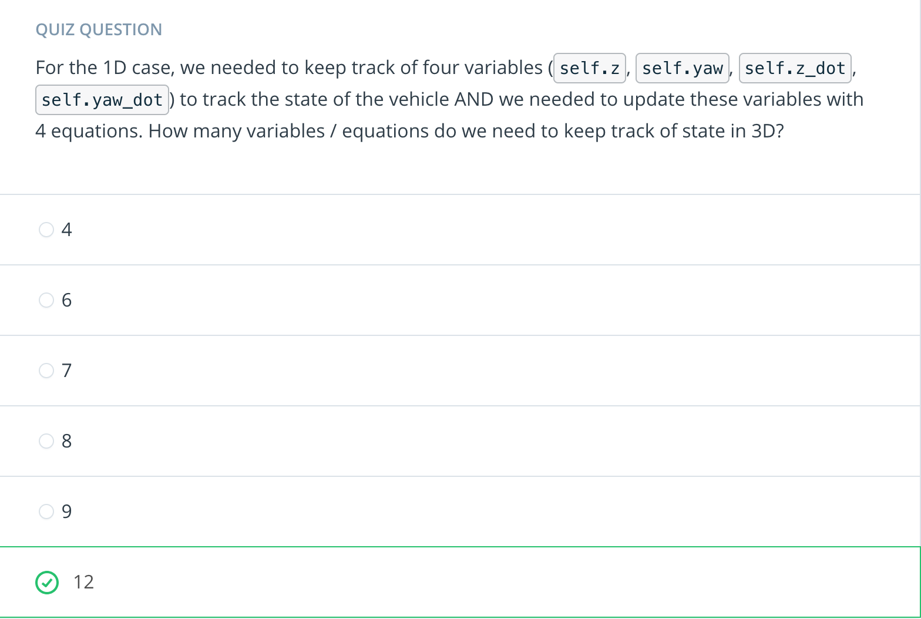

[16. Compact Representations of State](https://classroom.udacity.com/nanodegrees/nd787/parts/3619d672-ce5b-4a29-8a15-172cb667b5bb/modules/b78ec22c-5afe-444b-8719-b390bd2b2988/lessons/4cd7a5c4-12ad-4853-86cb-759d3833e856/concepts/c8554151-f55b-47ae-80cb-3db1a2097c28)

<https://www.youtube.com/watch?time_continue=2&v=y8EFM3RRZ6c>

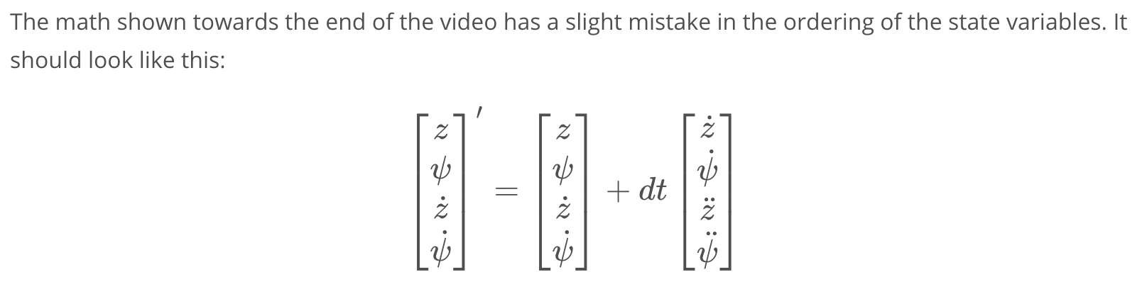

[17. Uncontrolled Drone Exercise](https://classroom.udacity.com/nanodegrees/nd787/parts/3619d672-ce5b-4a29-8a15-172cb667b5bb/modules/b78ec22c-5afe-444b-8719-b390bd2b2988/lessons/4cd7a5c4-12ad-4853-86cb-759d3833e856/concepts/55be0949-78cc-42c1-9812-a724f01c9c06)

[Uncontrolled 2D Drone.ipynb](https://viewb313237d.udacity-student-workspaces.com/notebooks/3.%20Uncontrolled%202D%20Drone.ipynb)

[18. Motion in Two Dimensions](https://classroom.udacity.com/nanodegrees/nd787/parts/3619d672-ce5b-4a29-8a15-172cb667b5bb/modules/b78ec22c-5afe-444b-8719-b390bd2b2988/lessons/4cd7a5c4-12ad-4853-86cb-759d3833e856/concepts/5c63e26c-db28-4fca-bad7-1b345ce45e8c)

<https://www.youtube.com/watch?v=KFcsGXHBLkc>

[19. Decomposing Thrust Vectors](https://classroom.udacity.com/nanodegrees/nd787/parts/3619d672-ce5b-4a29-8a15-172cb667b5bb/modules/b78ec22c-5afe-444b-8719-b390bd2b2988/lessons/4cd7a5c4-12ad-4853-86cb-759d3833e856/concepts/3acb499f-6297-4c97-89ef-65be6d7c4d53)

<https://www.youtube.com/watch?time_continue=1&v=TbHVgjtZ8qI>

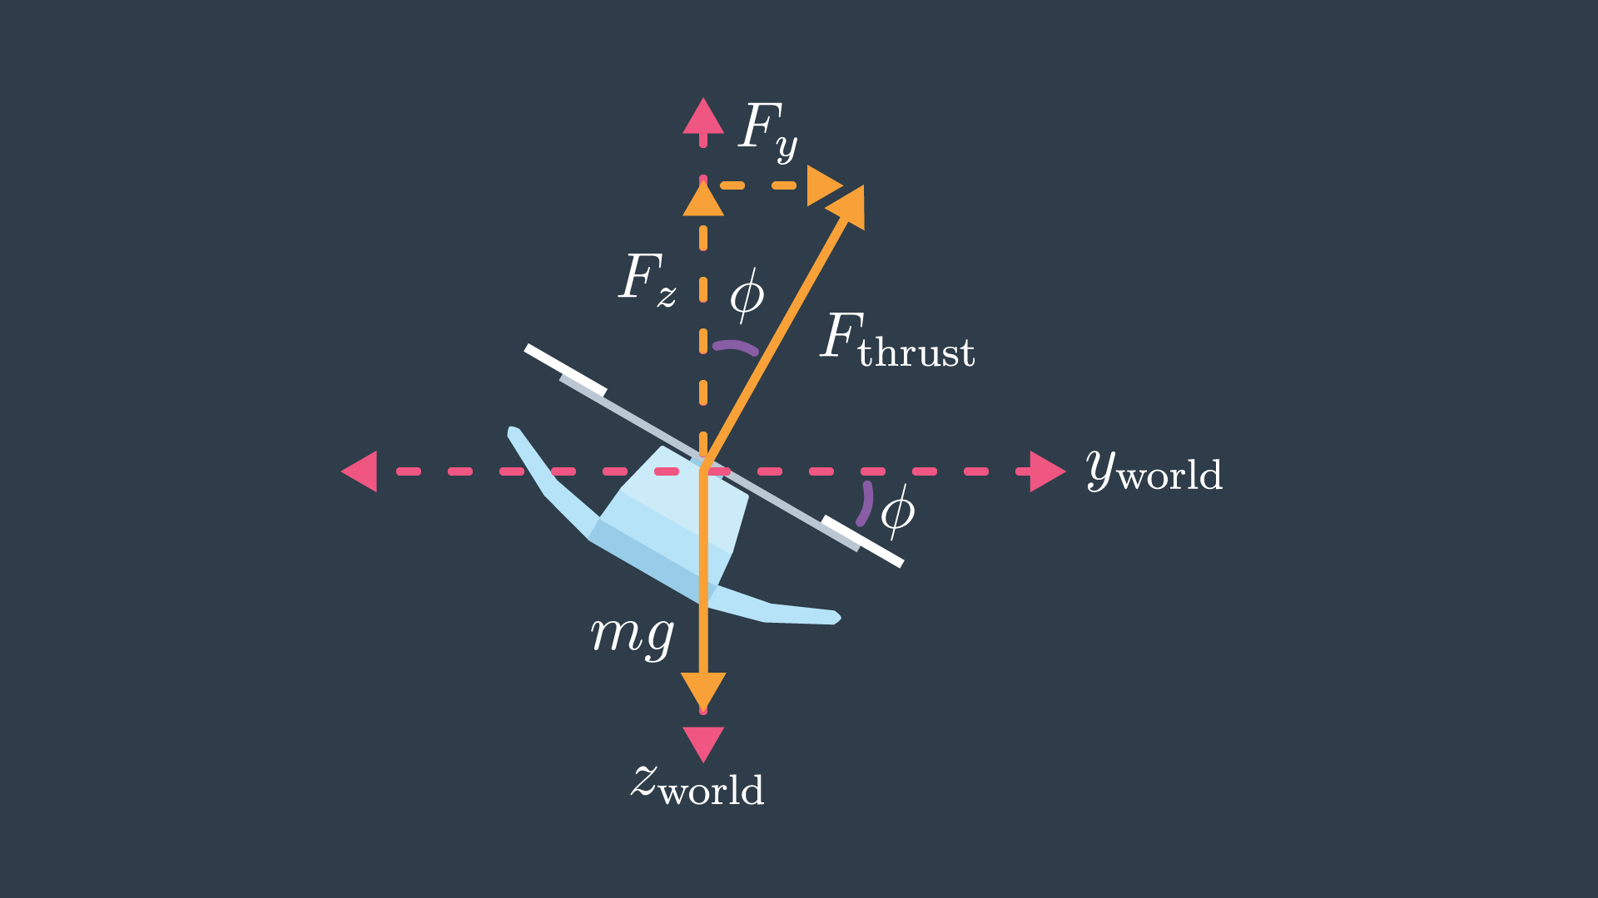

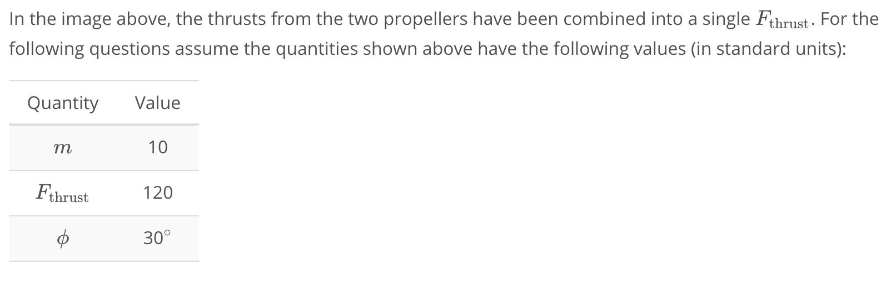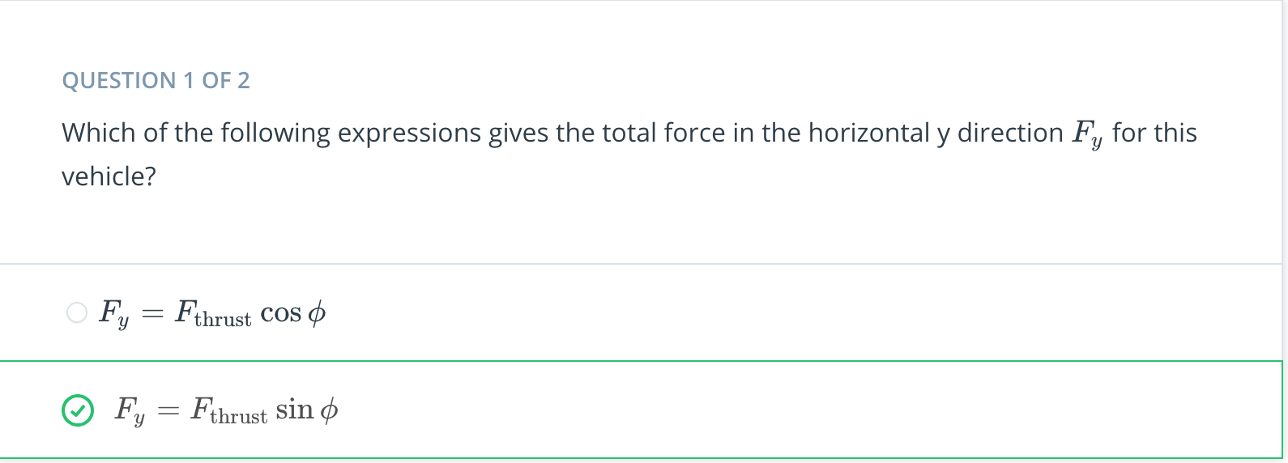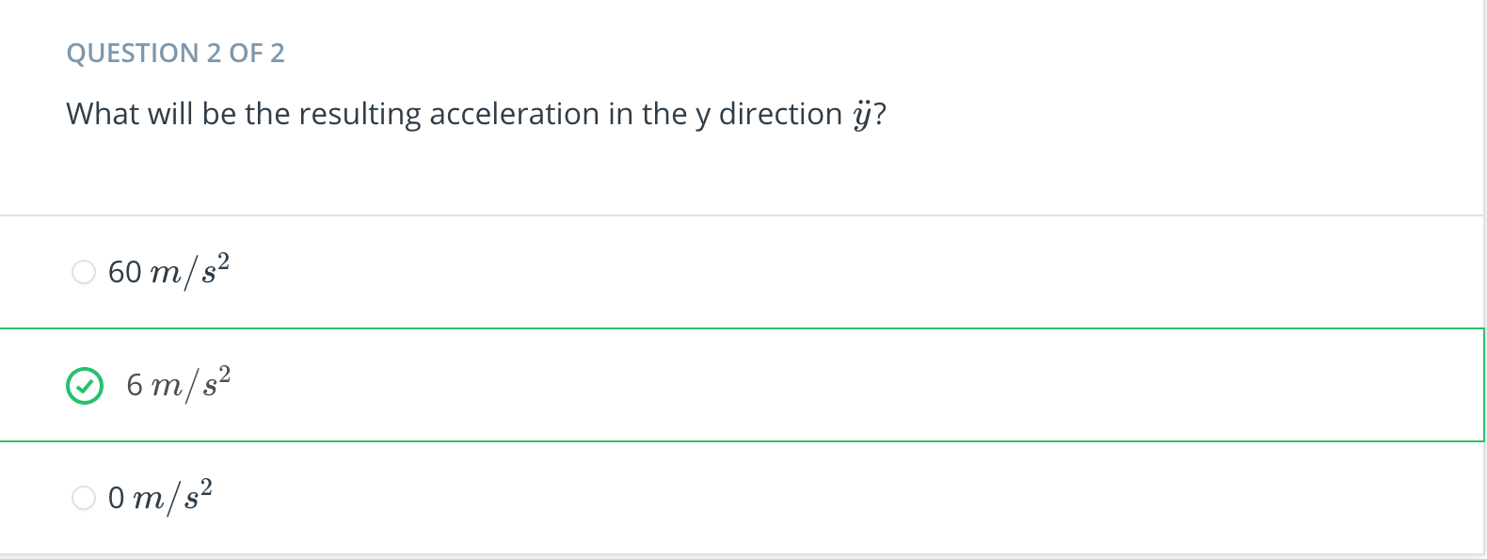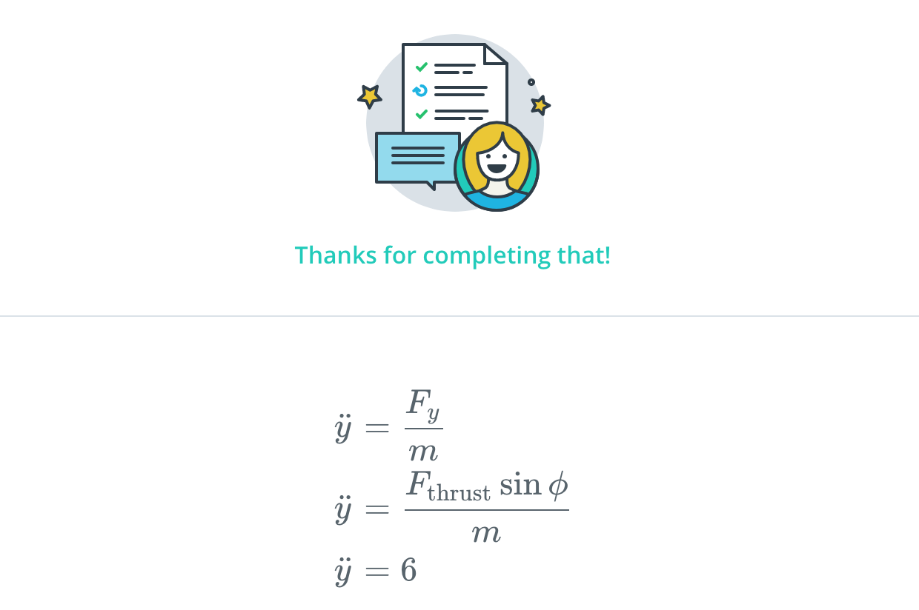

[20. Calculating Moments](https://classroom.udacity.com/nanodegrees/nd787/parts/3619d672-ce5b-4a29-8a15-172cb667b5bb/modules/b78ec22c-5afe-444b-8719-b390bd2b2988/lessons/4cd7a5c4-12ad-4853-86cb-759d3833e856/concepts/1f2984f9-5f34-4966-91ed-c5f163e1d769)

<https://www.youtube.com/watch?v=v2vVHXVv2rU>

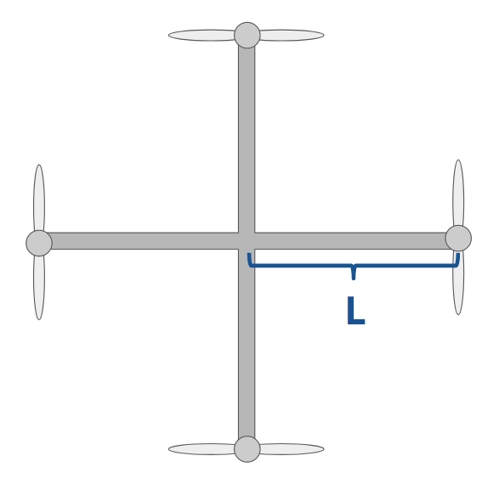

Consider the quadrotor shown above. The length of each arm is L*L*.

How would we calculate torques **If** we decided to align the drone's "body" frame with the arms? If that were the case, we'd have something like the following:

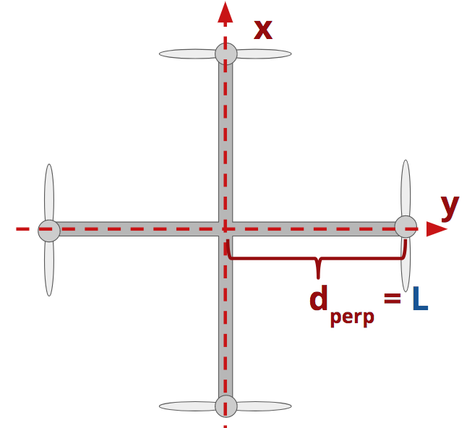

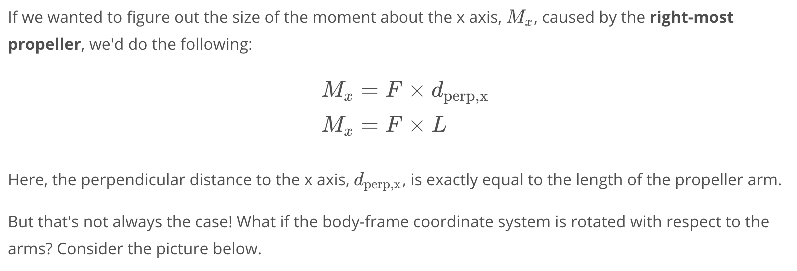

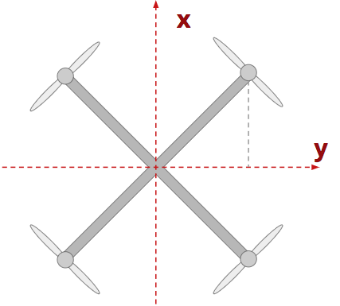

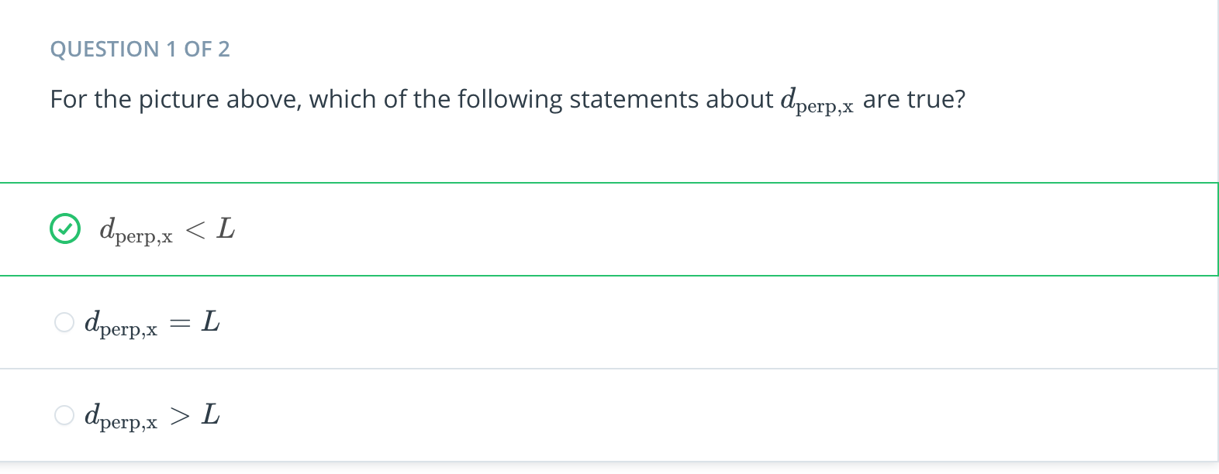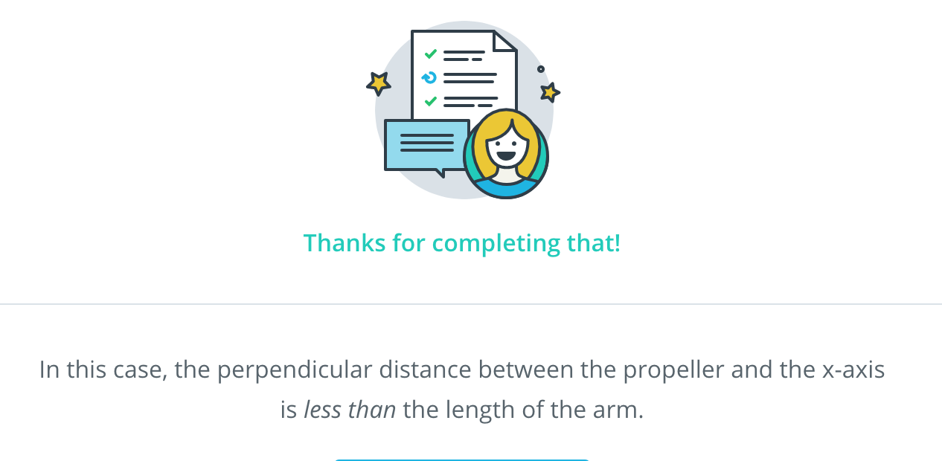

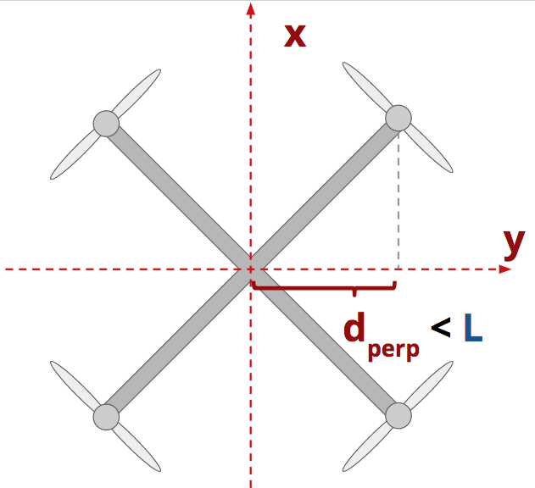

As the picture above shows, the perpendicular distance from the propeller to the x-axis is *less than* the length of the propeller arm.

In fact, if you look at the y-axis, the propeller arm, and the vertical line I've added to the diagram, you can start to see a right triangle emerge...

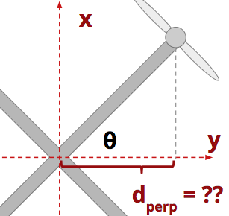

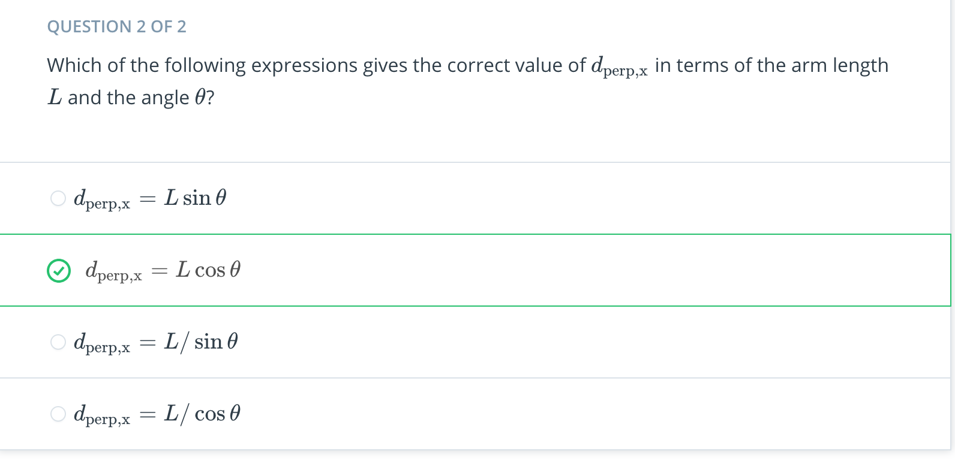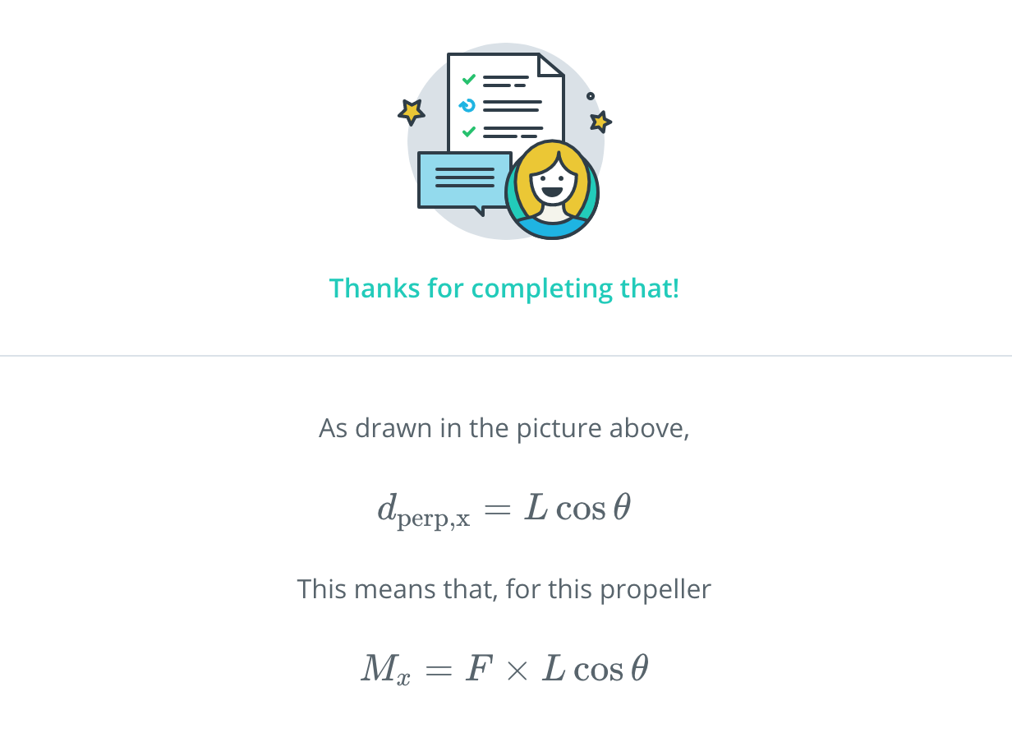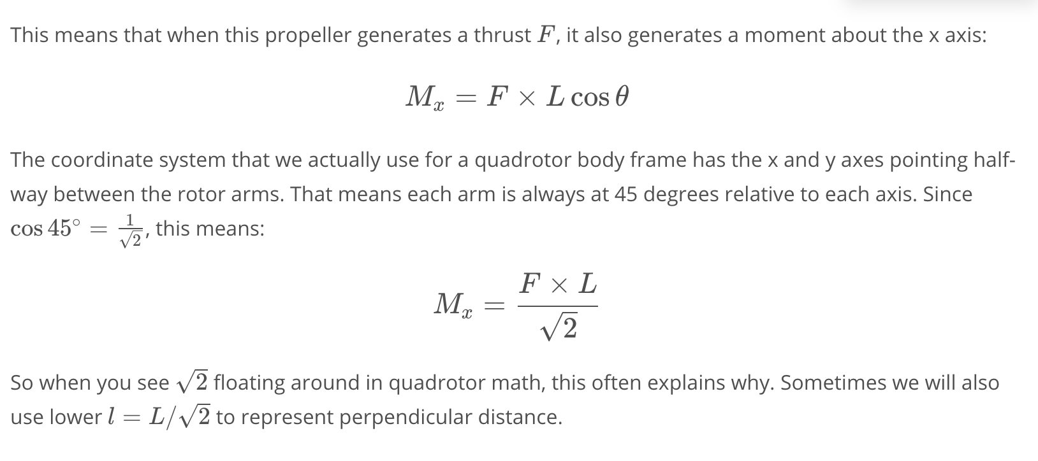

[21. Rotation Rates to Moments and Thrusts](https://classroom.udacity.com/nanodegrees/nd787/parts/3619d672-ce5b-4a29-8a15-172cb667b5bb/modules/b78ec22c-5afe-444b-8719-b390bd2b2988/lessons/4cd7a5c4-12ad-4853-86cb-759d3833e856/concepts/686c2fa2-4c44-47d4-b6fb-181909de5e4c)

<https://www.youtube.com/watch?time_continue=7&v=OzZpPpgL_Hs>

[22. Calculating Accelerations in 2D Exercise](https://classroom.udacity.com/nanodegrees/nd787/parts/3619d672-ce5b-4a29-8a15-172cb667b5bb/modules/b78ec22c-5afe-444b-8719-b390bd2b2988/lessons/4cd7a5c4-12ad-4853-86cb-759d3833e856/concepts/17b1a034-38c7-4499-91eb-ea180e51060b)

## **Rotation Rates to Moments and Thrusts**

**def** **get_thrust_and_moment**(self):  
 """Helper function which calculates and returns the   
 collective thrust and the moment about the X axis"""  
  
 f1 = self.k_f * self.omega_1 ** 2  
 f2 = self.k_f * self.omega_2 ** 2  
  
 *# c is often used to indicate "collective" thrust*  
 c = f1 + f2  
  
 M_x = (f1 - f2) * self.l  
 **return** c, M_x

In the exercise below you'll probably want to use this function as you implement three new methods in the Drone2D class.

[4. Calculating Accelerations in 2D.ipynb](https://viewb313237d.udacity-student-workspaces.com/notebooks/4.%20Calculating%20Accelerations%20in%202D.ipynb)

[23. Controlling a 2D Quad](https://classroom.udacity.com/nanodegrees/nd787/parts/3619d672-ce5b-4a29-8a15-172cb667b5bb/modules/b78ec22c-5afe-444b-8719-b390bd2b2988/lessons/4cd7a5c4-12ad-4853-86cb-759d3833e856/concepts/6cc55c76-a755-45f5-83f2-9da9068d0db2)

<https://www.youtube.com/watch?time_continue=2&v=2lBmddVJtOE>

[24. Controlling a 2D Drone Exercise](https://classroom.udacity.com/nanodegrees/nd787/parts/3619d672-ce5b-4a29-8a15-172cb667b5bb/modules/b78ec22c-5afe-444b-8719-b390bd2b2988/lessons/4cd7a5c4-12ad-4853-86cb-759d3833e856/concepts/30c8885b-8edd-45c1-91b9-96d82cfe6433)

[5. Controlling a 2D Quad.ipynb](https://viewb313237d.udacity-student-workspaces.com/notebooks/5.%20Controlling%20a%202D%20Quad.ipynb)

[25. Summary](https://classroom.udacity.com/nanodegrees/nd787/parts/3619d672-ce5b-4a29-8a15-172cb667b5bb/modules/b78ec22c-5afe-444b-8719-b390bd2b2988/lessons/4cd7a5c4-12ad-4853-86cb-759d3833e856/concepts/56a1fbd6-b4ef-4841-845a-341d2b6d6c22)

<https://www.youtube.com/watch?v=1FD7OuJ6_bg>